W205 summer 2017 section 2 – Lab04 - K Iwasaki

**SUBMISSION 1:**

*Create an RDD with tuples were the there is a key and a value. But in contrast to the example above the key is removed from the value portion of the key-value tuple. Submit the code and a print out of the first tuple.*

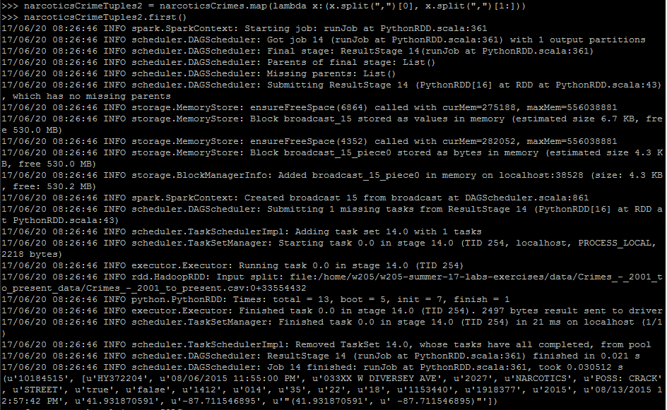

**SUBMISSION 2:** *Submit the the code for executing the above query as a Spark SQL python call. Also submit the number of rows in the result*



